**Finding Frontiers Project Report**



Project Implementation Report

***Group: Finding Frontiers***

**Apoorva Mahajan, Ayush Thoniparambil Saseendran, and Prasanna Lakshmi Chelliboyina**

**IST 659 Fall 2023**

**TABLE OF CONTENTS:**

1. Project Summary

2. PURPOSE OF PROJECT

3. ER SPREADSHEET

4. CONCEPTUAL DATA MODEL

5. LOGICAL DATA MODEL

6. BASIC LAYOUT OF POWER APPS

7. SQL UP/DOWN SCRIPTS

8. DEMO OF UI

**PROJECT SUMMARY:**

In response to the evolving needs of the modern travel and tourism industry, our academic project focuses on the development of a Travel Management System utilizing SQL databases and PowerApps. This system aims to address the increasing demand for centralized tools to streamline travel-related processes.

The application's frontend and backend functionalities are demonstrated, showcasing its user-friendly interface and robust data management capabilities. For end-users, the system offers features like trip planning, itinerary creation, bookings, and post-trip reviews.

Meanwhile, employees benefit from functionalities such as itinerary confirmation and business intelligence visualization. Identified areas for improvement include data source optimization and formula simplification in PowerApps.

**Purpose of the project:**

The purpose of our project is to contribute a cutting-edge solution to the travel and tourism industry by developing a Travel Management System grounded in SQL databases and PowerApps. This system is designed to address the contemporary challenges faced by travel organizers and service providers in managing bookings, itineraries, and coordination.

The project's purpose is to streamline the travel booking process, centralize information management, and enhance overall operational efficiency. Through this initiative, we aim to contribute valuable insights, exploring the integration of SQL and PowerApps as a solution for comprehensive travel management in the digital era.

**ER Spreadsheet Model:**

|  |  |  |  |
| --- | --- | --- | --- |
| **Entities and Attributes** | | | |
| **Entity** | **Attribute** | **Props** | **Description** |
| customer | cust_id | RU | Customer ID |
|  | cust_first_name | R | Customer First name |
|  | cust_last_name |  | Customer last name |
|  | cust_address | RC | customer address |
|  | cust_email | RU | customer email |
|  | cust_phone_number | U | customer phone number |
|  | cust_city | R | customer city |
|  | cust_zip_code | R | customer zip code |
|  |  |  |  |
|  |  |  |  |
| Destinations | dest_id | RU | Destination ID |
|  | dest_name | R | Destination Name |
|  | dest_description | R | Description of Destination |
|  | dest_location | R | Location |
|  |  |  |  |
| Places In Destination | pid_id | RU | Place ID |
|  | pid_id_dest | R | Destination ID |
|  | pid_name | R | Place Name |
|  |  |  |  |
| Accommodations | acco_id | RU | Accommodation ID |
|  | acco_name | R | Accommodation Name |
|  | acco_id_dest | R | Destination ID |
|  | acco_type | R | Type |
|  | acco_price_per_night | R | Price Per Night |
|  | acco_availability | R | Availability |
|  | acco_room_capacity | R | Room Capacity |
|  |  |  |  |
| Flights | flig_id | RU | Flight ID |
|  | flig_number | R | Flight Number |
|  | flig_id_dest | R | Destination ID |
|  | flig_departure_location | R | Departure Location |
|  | flig_arrival_location | R | Arrival Location |
|  | flig_departure_dt | R | Departure Date Time |
|  | flig_arrival_dt | R | Arrival Date Time |
|  | flig_price | R | Price |
|  | flig_airline | R | Airline |
|  |  |  |  |
| Activities | acti_id | RU | Activity ID |
|  | acti_id_dest | R | Destination ID |
|  | acti_name | R | Activity Name |
|  | acti_description | R | Description |
|  | acti_price | R | Price |
|  | acti_duration | R | Duration |
|  | acti_availability | R | Availability |
|  |  |  |  |
| Packages | pack_id | RU | Package ID |
|  | pack_name | R | Package Name |
|  | pack_id_dest | R | Destination ID |
|  | pack_id_acco | R | Accommodation ID |
|  | pack_id_flig | R | Flight ID |
|  | pack_id_acti | R | Activity ID |
|  | pack_price | R | Price |
|  | pack_type | R | Type |
|  | pack_description | R | Description |
|  | pack_availability | R | Availability |
|  |  |  |  |
| Bookings | book_id | RU | Booking ID |
|  | book_id_cust | R | Customer ID |
|  | book_id_dest | R | Destination ID |
|  | book_id_acco |  | Accommodation ID |
|  | book_id_flig |  | Flight ID |
|  | book_id_acti |  | Activity ID |
|  | book_id_pack |  | Package ID |
|  | book_dt | R | Booking Date |
|  | book_check_in_dt | R | Check In Date |
|  | book_check_out_dt | R | Check Out Date |
|  | book_total_price | R | Total Price |
|  | book_status | R | Booking Status |
|  |  |  |  |
| Reviews | revi_id | RU | Review ID |
|  | revi_id_cust | R | Customer ID |
|  | revi_id_dest |  | Destination ID |
|  | revi_id_pack |  | Package ID |
|  | revi_id_acco |  | Accommodation ID |
|  | revi_id_flig |  | Flight ID |
|  | revi_id_acti |  | Activity ID |
|  | revi_rating | R | Rating |
|  | revi_review | R | Review Text |
|  |  |  |  |
| Payments | pay_id | RU | Payment ID |
|  | pay_id_cust | R | Customer ID |
|  | pay_id_book | R | Booking ID |
|  | pay_method | R | Payment Method |
|  | pay_transaction_dt | R | Transaction Date |
|  | pay_total_amount | R | Total Amount |
|  | pay_transaction_status | R | Transaction Status |

**Conceptual Model:**

**Logical Model:**

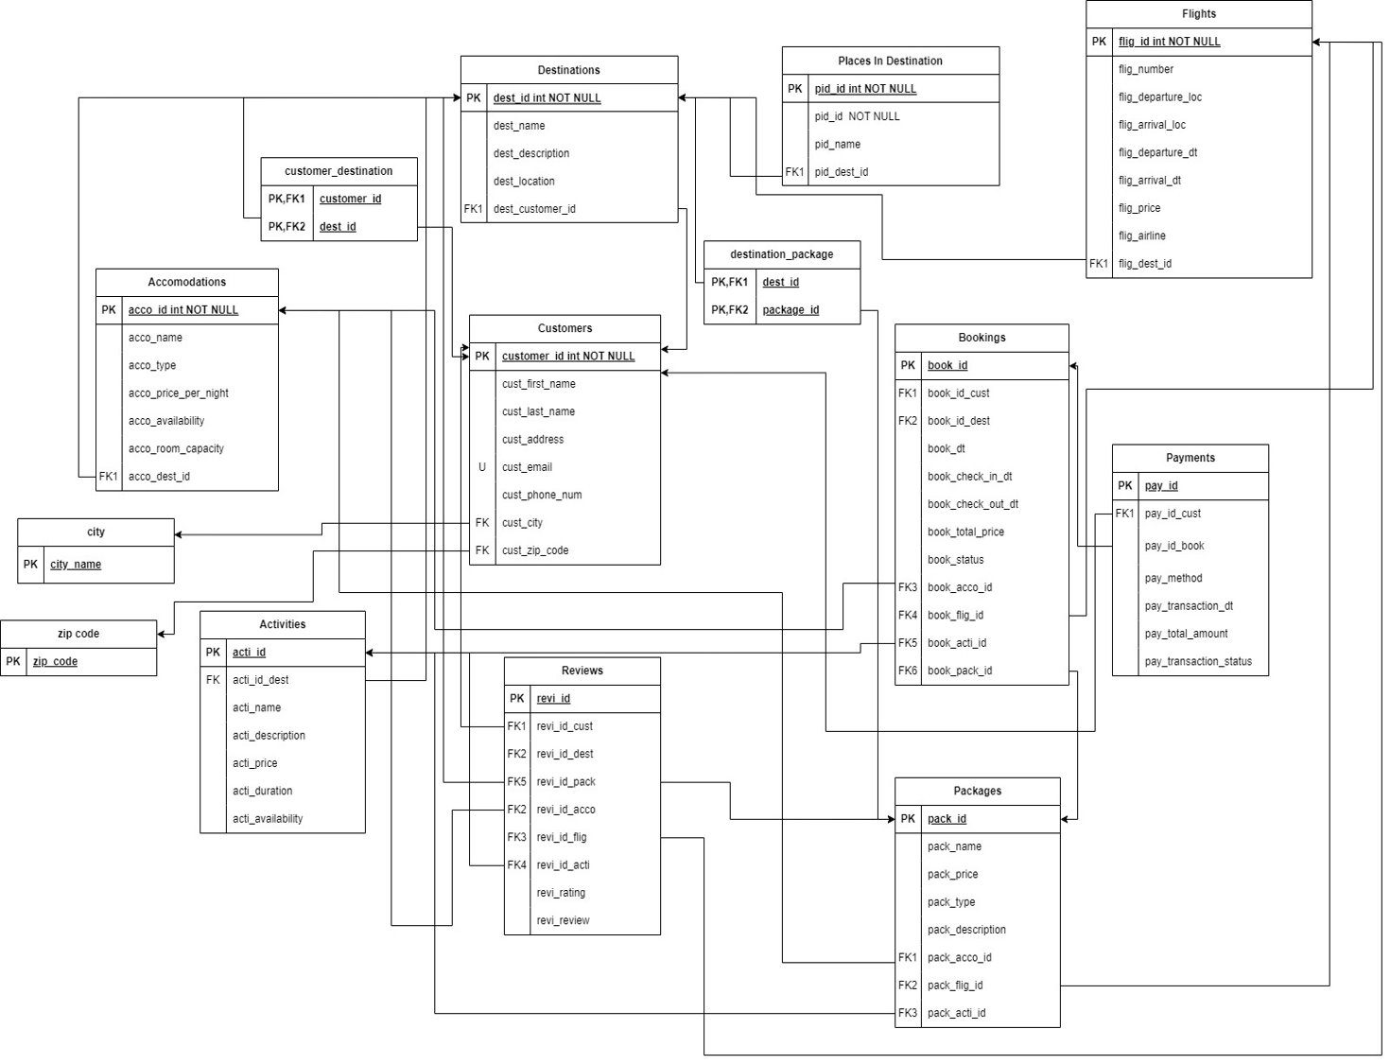

**BASIC LAYOUT OF POWER APPS**

1. Common Main screen for Finding Frontier’s travel booking application



1. User Login screen

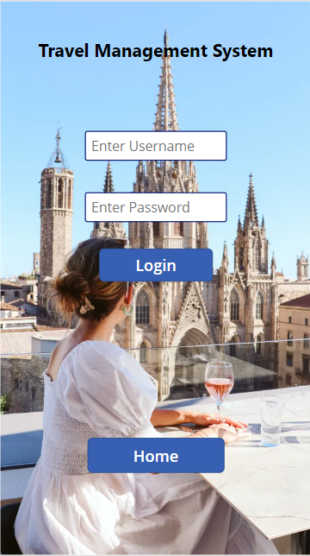

1. Error screen in case of incorrect username/password

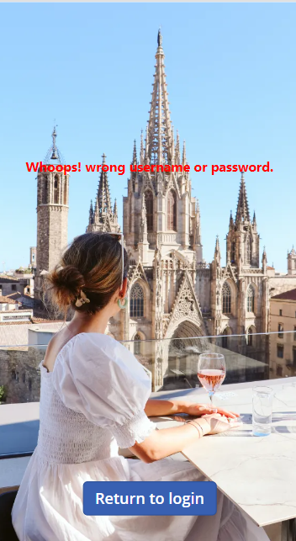

1. User / Customer Main booking screen post login

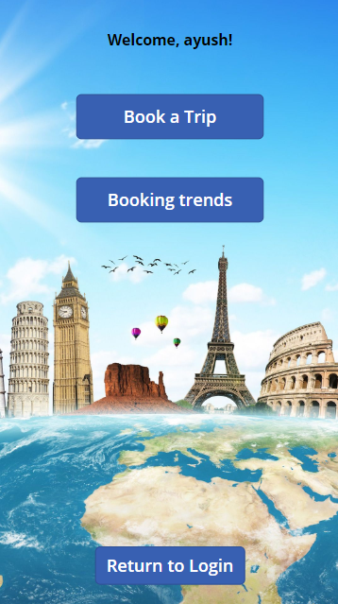

1. Customer’s Booking screens for filling in details of the trip

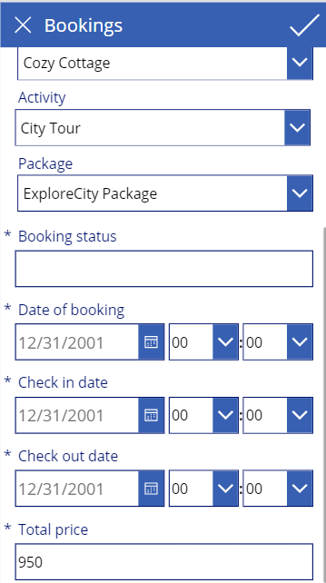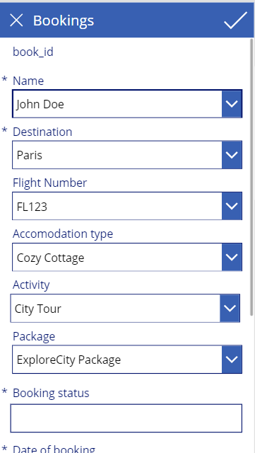

1. Data visualization Dashboard functionalities for Customer

*(scroll below for the entire screen)*

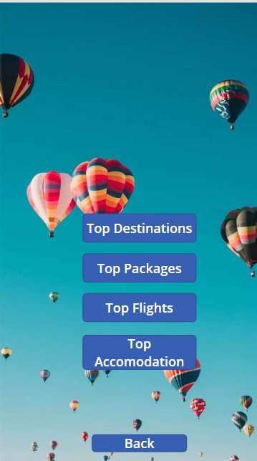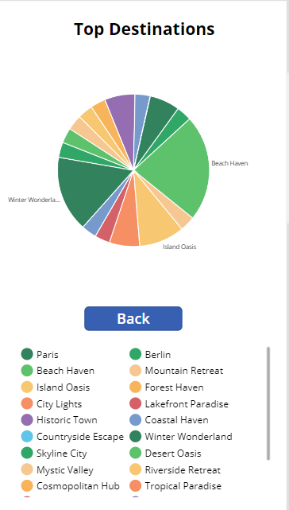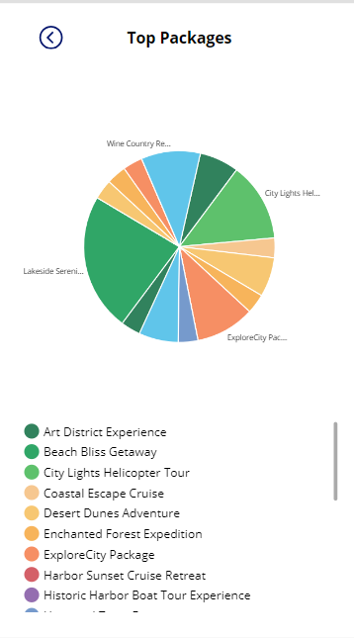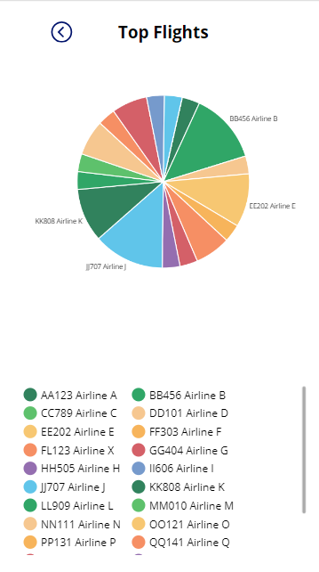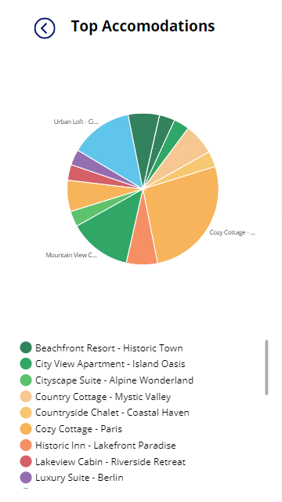

1. Employee Login Screen

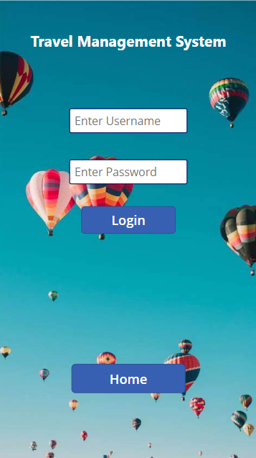

1. Error screen in case of incorrect username/password

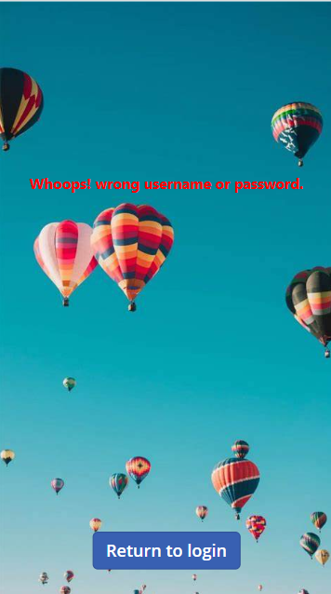

1. Employee Main screen post-login

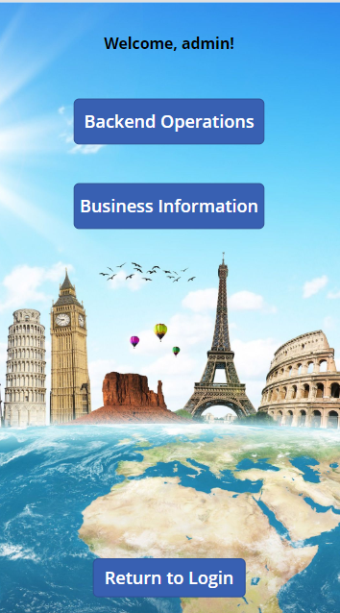

1. Backend operations functionality list

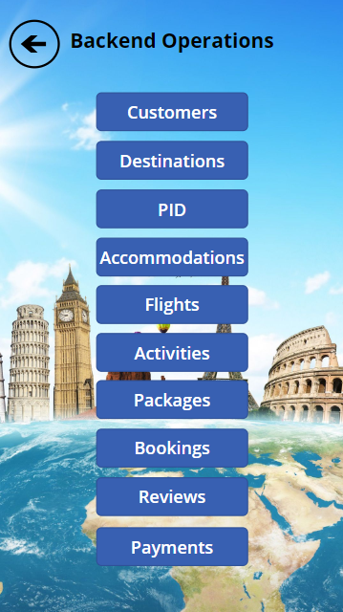

1. Each operational database’s screens

*(scroll below for the entire screen)*

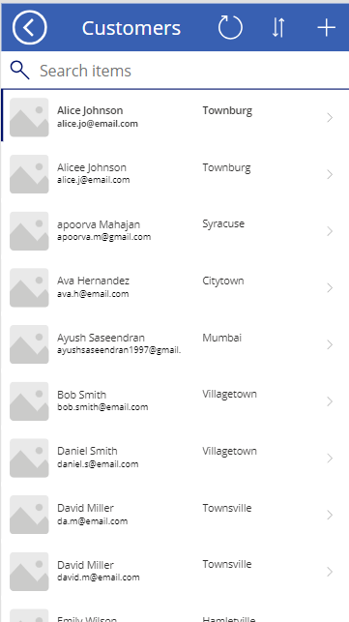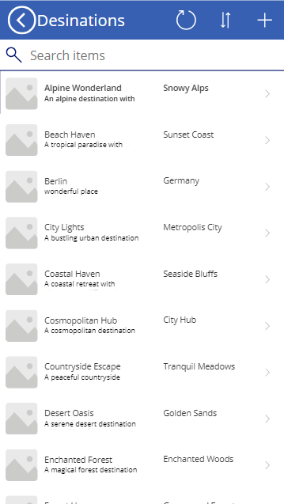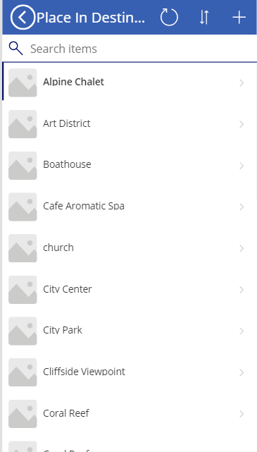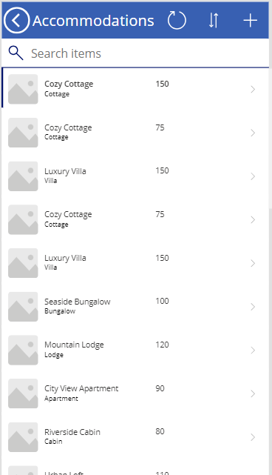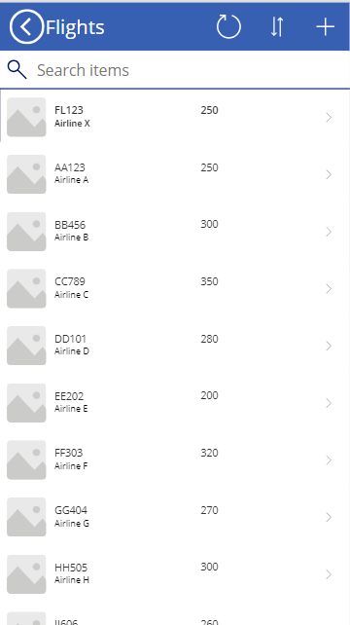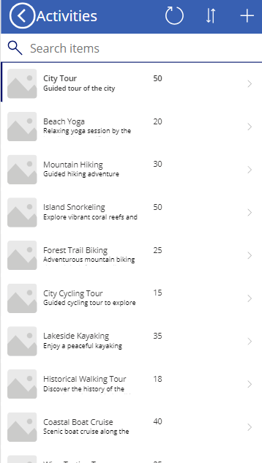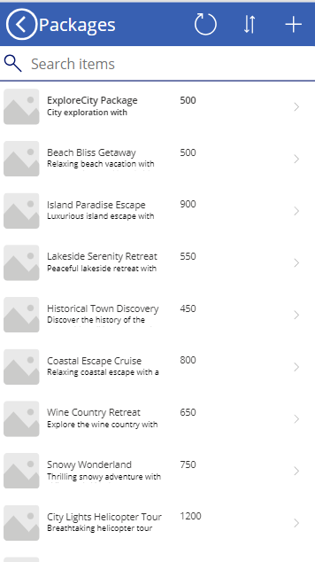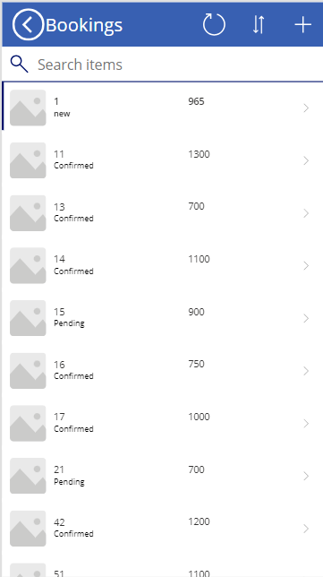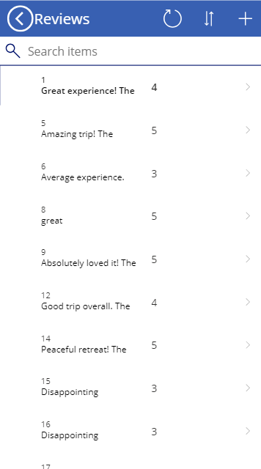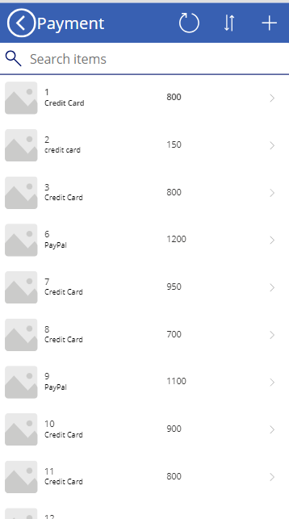

1. Employee’s view of Customer’s booking details and Confirmation Pending status

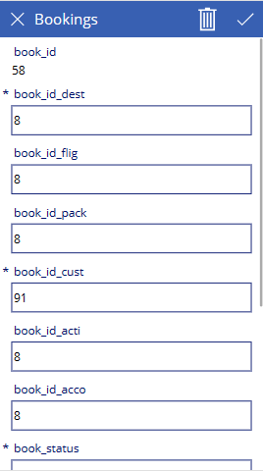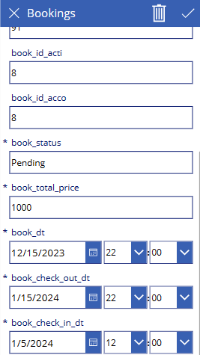

1. Customer’s booking confirmation functionality from the backend by the Employee

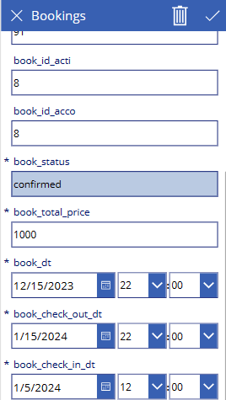

1. Business information Dashboard functionalities for Employee / Business owners

